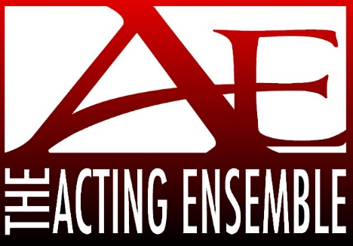
2018 Trivia Night Registration Form
March 24, 2018
Di Loreto Club 914 Division St., Mishawaka
Team Name __________________________ Contact Name ______________
Phone _____________ Email ______________________
*** Team Registration will be under Team Name at event ***
Total Amount Due $100 for team - up to 10 players
Payment: ___Check Enclosed ___ Visa ___ MasterCard ___ Discover

Card Number _____________________________________________

Name on Card ____________________________________________

Expiration Date_________ Security Code ________

Billing Address (include zip code): __________________________________________

_________________________________________

Authorizing Signature_______________________________________________

Please Return to: *** Remember ALL donations are tax deductible***
Acting Ensemble Trivia Night
P O Box 756
South Bend, IN 46624

REGISTRATION MUST BE SUBMITTED BY MARCH 17, 2018

574-807-0108 www.actingensemble.com – melissa@actingensemble.com

