Presented by:

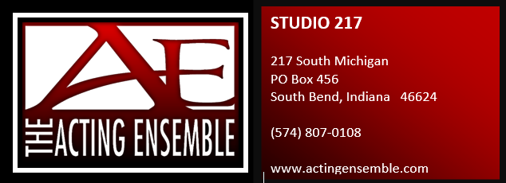1

$100 per table of up to 10 players OR $12 per individual registration

TEAMS MUST PRE-REGISTER by March 17th

Register online at [www.actingensemble.com](http://www.actingensemble.com) or email [teri@actingensemble.com](mailto:teri@actingensemble.com) for form

Heads or Tails – Tip Boards – 50/50

SILENT AUCTION – Prize for Best Decorated Table

Cash payout for 1st Place Trivia Winners

Cash bar – NO OUTSIDE ALCOHOL ALLOWED – Trivia Night is Age 21 +

QUESTIONS 574-807-0108EMAIL [teri@actingensemble.com](mailto:teri@actingensemble.com) or melissa@actingensemble.com

SATURDAY, MARCH 24, 2018

Doors open 5:30 pm Trivia 7PM

Di Loreto Club

914 Division Street, Mishawaka

