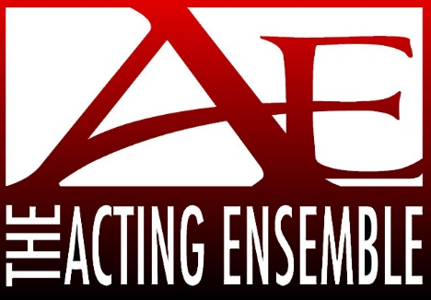
2024 Trivia Night Registration Form
April 6, 2024
“A NIGHT AT THE RACES”
St. Stanislaus Tulip Road., South Bend
Doors open for silent auction at 5:00pm
Trivia starts at 6:00pm

Team Name ______________________ Contact Name __________________
Phone _____________ Email ______________________
$120 for team - up to 8 players Individual Players - $20 each

___Check Enclosed
___ Visa/MasterCard/Discover online at www.actingensemble.com/support-us
___Venmo to www.venmo.com/Melissa-Gard-5

** Remember ALL donations are tax deductible***

Please Return to:
Acting Ensemble Trivia Night
P O Box 756
South Bend, IN 46624

REGISTRATION MUST BE SUBMITTED BY MARCH 30, 2024

574-217-8873 www.actingensemble.com melissa@actingensemble.com

